**WIFI**

|  |  |
| --- | --- |
| Reviewed by | V. Mamatha |
| Prepared by | M. Venkatanarayana |

**Wi-Fi: -** It is a wireless technology used to connect computers, tablets, smartphones and other devices to the internet. Wi-Fi is the radio signal sent from a wireless router to a nearby device, which translates the signal into data you can see and use.

**Hedy Lamar** was an Austrian-American actress and inventor who pioneered the technology that would one day form the basis for today's WIFI, GPS, and Bluetooth communication systems.

WIFI was invented and first released for consumers in **1997** when a committee called 802.11 was created. It leads to the creation of IEEE802. 11, which refers to a set of standards that define communication for wireless local area networks (WLANs).

WIFI-------🡪WIRELESS FIDELITY

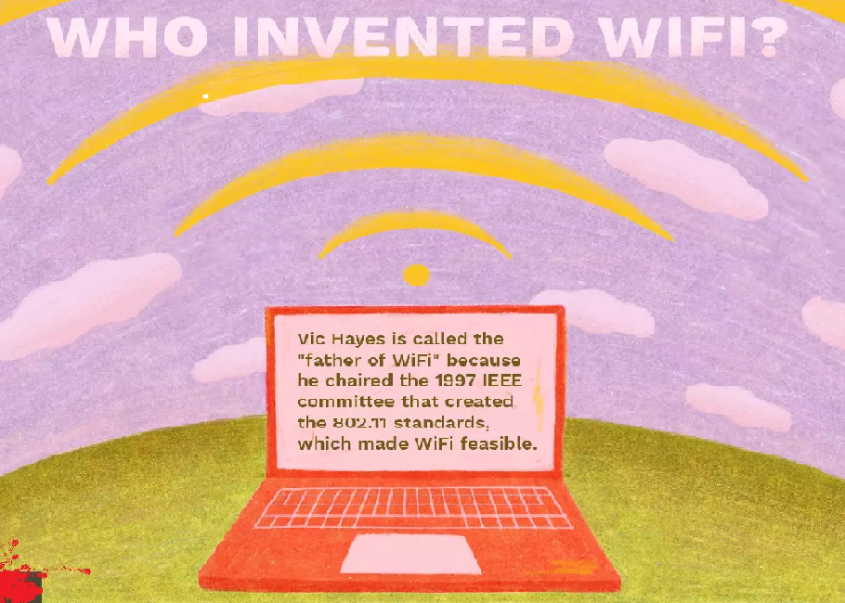

|  |  |  |
| --- | --- | --- |
| WIFI ADVANTAGES | WIFI DISADVANTAGES | USES AND APPLICAIONS |
| 1. **MOBILITY** | **1.SECURITY LESS** | **1.BROWSING INTERNETR** |
| **2.CONVINIENCE** | **2.SPEED IS LESS** | **2.SHARING FILES** |
| **3.PRODUCTIVITY** | **3.LIMITED RANGE** | **3.VEDIO CONFERENCE** |
| **4.HIGH COST** | **4.LOT OF RADIATION** | **4.MOBILES, LAPTOPS, TV’S** |
| **5.EXPAND USERS EASILY** | **5.HIGH POWER CONSUMPTION** | **5.ROUTERS, ACCESS POINTS** |

Difference between WIFI and Ethernet: --

A WIFI connection transmits data via wireless signals, while an Ethernet connection transmits data over cable. No cables are needed to access a WIFI connection, providing greater mobility for users who can connect to a network or the Internet while moving freely around a space.An Ethernet connection is generally faster than a WIFI connection and provides greater reliability And security.

|  |  |  |
| --- | --- | --- |
| **S. No** | **Wired Network** | **Wireless Network** |
| 1. | A wired network employs wires to link devices to the Internet or another network, such as laptops or desktop PCs. | “Wireless” means without wire, media that is made up of electromagnetic waves (EM Waves) or infrared waves. Antennas or sensors will be present on all wireless devices |
| 2. | Faster transmission speed | Slow transmission speed |
| 3. | Propagation delay is Low | Propagation delay is high |
| 4. | More Secure & hence Reliable | Less Secure & hence less Reliable |
| 5. | Devices must be hard-wired | Installation is Quick |
| 6. | Less Expensive | More Expensive |
| 7. | High installation & maintenance cost | Low installation & maintenance cost |
| 8. | Hub, Switch, etc. devices are used | Wireless routers, access points, etc. are used. |

**MODES AND ARCHITECTURE OF WIFI: -**

**1.ADHOC**

**2.INFRASTRUCTURE**

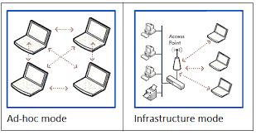

**1.ADHOC MODE OR IBSS (INDIPENDENT BASIC SERVICE SET)**

Ad-hoc mode refers to a wireless network structure where devices can communicate directly with each other. It is an additional feature that is specified in the 802.11 set of standards, which is referred to as an independent basic service set (IBSS). this type of wireless network is also called peer-to-peer mode.

Here no need router, access point, or any centralising device for communication. Any one device can Acts as access point and provides communication.

**WORKING: -**

1.BEACONS

2.PROBE RQUEST

3.PROBE RESPONSE

4.INVITATION OR AUTHENTICATION REQUEST

5.ACCEPT OR DSCLINE RESPONSE

**In IBSS no need internet and IP address It works through MAC address.**

**EX: - WIFI DIRECT, BLUETOOTH, SHARE IT.**

**2.INFRASTRUCTURE MODE**

Tis mode Works through Access point or any centralising device is required.

THESE MODE IS TWO TYPES: -

* BSS----------🡪basic service set
* ESS----------🡪extended service set

STATION(STA): - Any device that contains 802.11-compliant MAC and PHY interface to the wireless medium (WM). It supports WIFI capability to get access is called station.

EX: - mobiles, laptops, watches, tv’s, washing machine.

ACCESS POINT (AP): -Any entity that has station functionality and provides access to the distribution services, via the wireless medium for associated STAs.

EX: - access point, router, modem, mobile

NOTE: - MOBILE ALSO HAVE PROVIDIG ACCESS LIKE HOTSPOT (SO IT’S A ACCESS POINT).

BASIC SERVICE SET(BSS): - A group of stations that are successfully synchronized for 802.11 communications. The communicating devices that make up a BSS are solely one AP with one or more client stations. Any stations that are members of a BSS have a layer 2 connection with the access point and are known as associated. All basic service sets can be identified by a 48-bit (6-octet) MAC address known as the basic service set identifier (BSSID). The BSSID address is the layer 2 identifier of each individual basic service set. Most often the BSSID address is the MAC address of the access point

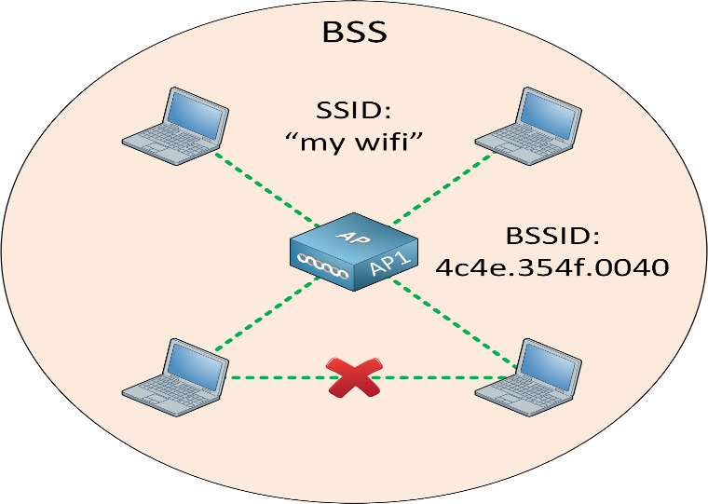

DISTRIBUTION SYSTEM (DS): - A system used to interconnect a set of basic service sets and integrated local area networks (LANs) to create an extended service set (ESS).

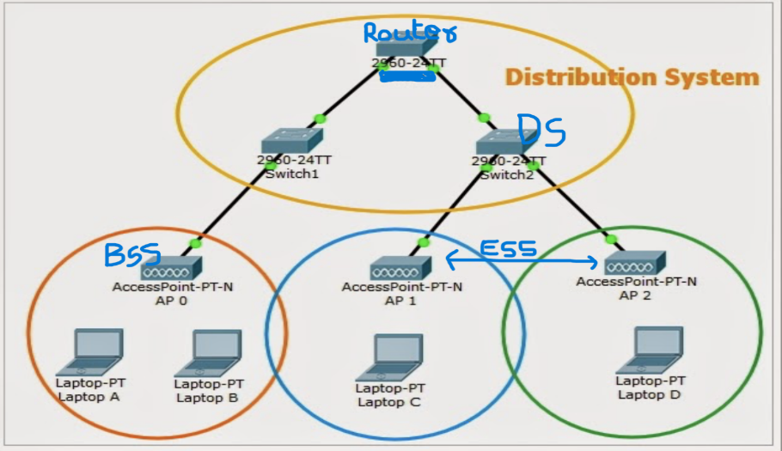

EXTENDED SERVICE SET: - An extended service set is one or more basic service sets connected by a distribution system medium. This an extended service set is a collection of multiple access points and their associated clients, all united by a single distribution system medium. The logical network name of an ESS is often called an extended service set identifier (ESSID), or, more simply, the service set identifier (SSID).

